Workshop 01
Organising your Team

Before the Workshop
Make sure you have looked at the following eLecture materials prior to your practical and workshop:
- Module Introduction
- Assessment Overview
- Claiming your eGrid
- Getting Help

Organising your Teams
In order to complete the work for this module you will be required to work in teams of 3-5 people.
During the first workshop you will organise yourselves into your teams, decide on a team name and select a topic for your system.
Team members MUST be timetabled for the same workshop, switching classes is not an option!
You will need to access the team spreadsheet for your workshop using the ‘Spreadsheet Link’ on the Blackboard module shell menu.
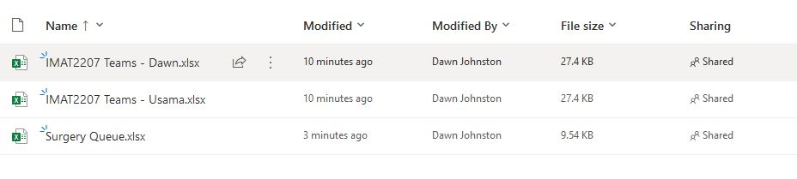
Sign in with your DMU account and you should see something like the following…
Open the spreadsheet belonging to your tutor and you should see something like this…

During your timetabled workshop ONLY, add your name and p number to the spreadsheet. Your tutor will talk you through the process.
Once everybody is added your tutor will filter the list. That way you and your tutor are able to see who is in the same workshop as you.
You need to then form a team with the people you would like to work with…but remember:
All team members need to be timetabled in the same workshop
Once you have decided who you are working with you need to decide on your team name. This may be anything you like. When you have agreed on your Team name, enter this for each team member in column E.
Once everybody has a team name on the spreadsheet your tutor will update columns A with the day and time of this workshop so that they know when you are all due to attend.
Over the next week or so your team will be allocated to an assessment schedule.
Don’t worry about the other columns on the spreadsheet, you will revisit this once you have completed the next handout.

What next?
Start working through the Practical handout ‘Getting Started on the Assessment Handout’. You and your team must complete the handout together.

